**How to create a design page in Figma**

1. You can access Figma from their website or Figma app. I am using the app.

2. Go to the top left side and choose to add a frame

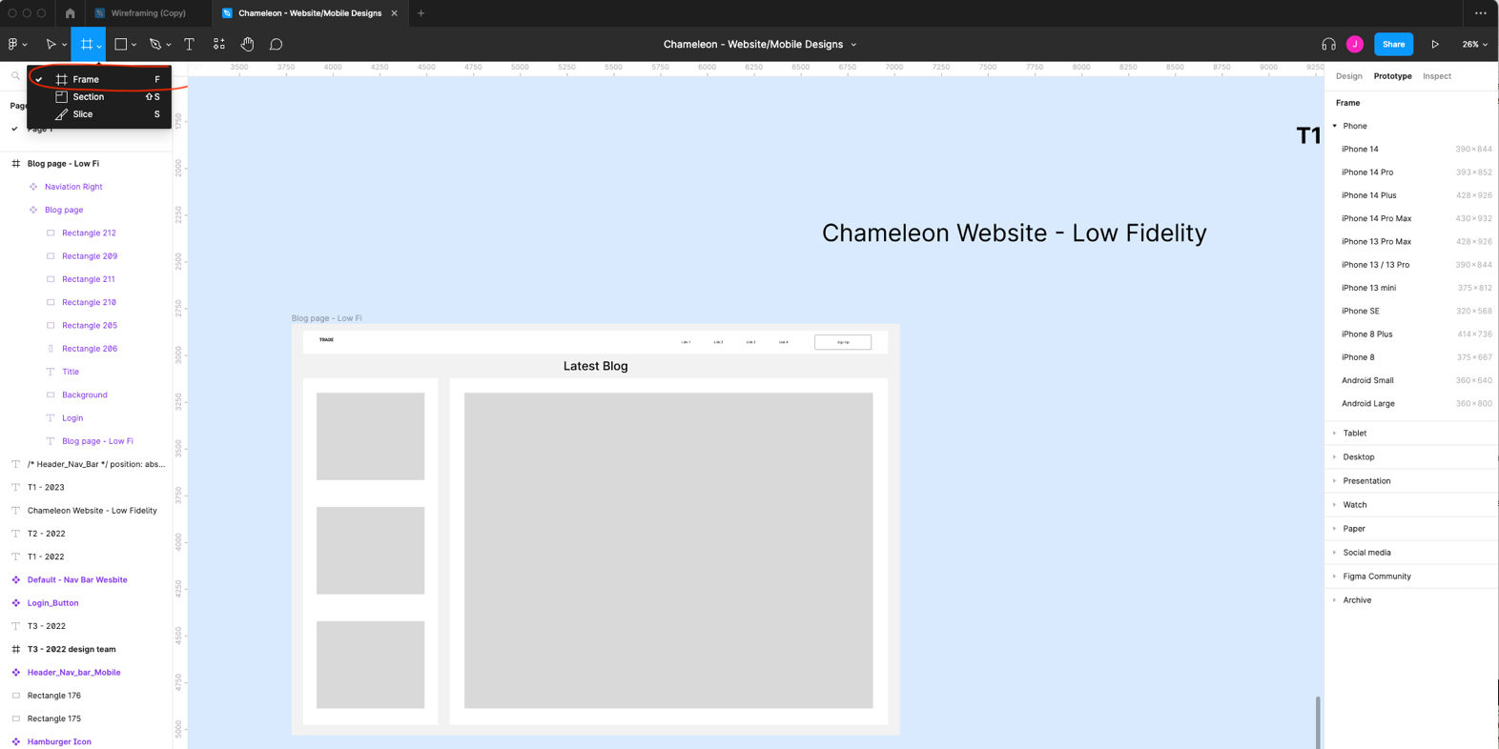

3. Go to the top left corner to choose Prototype

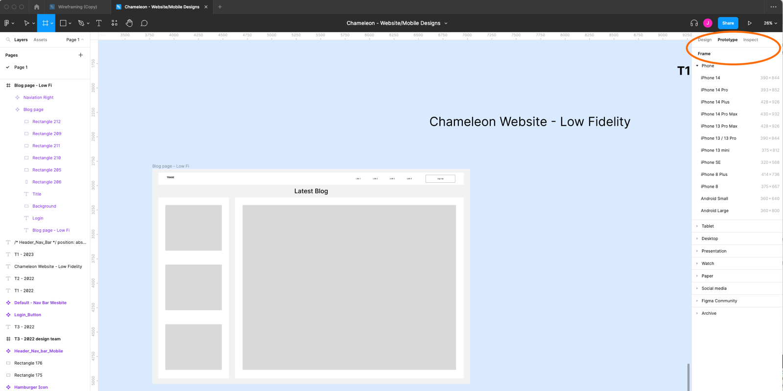

4. Choose appropriate options, such as Macbook Pro 14” for a web page or iPhone 14 Plus for a mobile app.

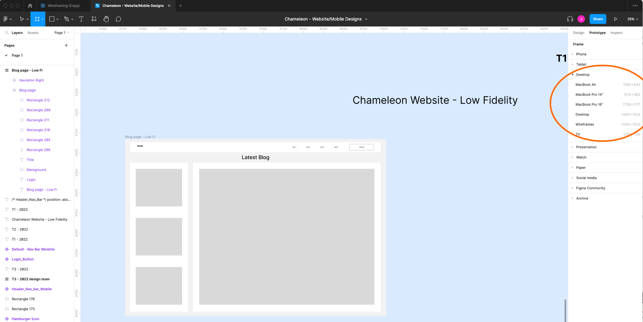

5. You will see the frame appear. This is where you can add elements such as buttons and menu bars. 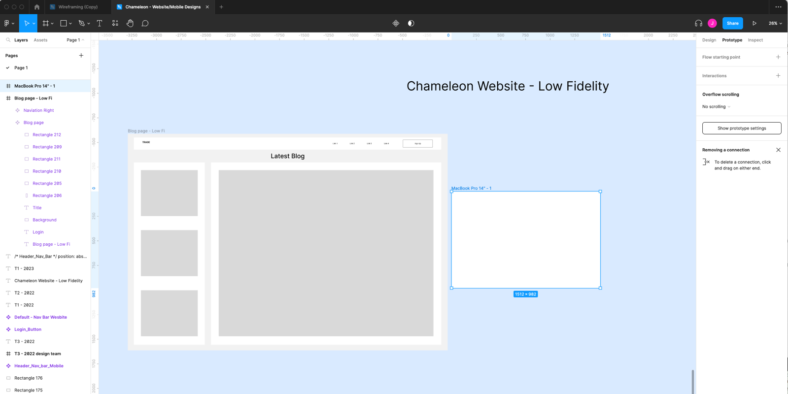



6. If you follow the steps, all elements will be organised in the same folder in the Layers. It will keep everything clear from being mixed up in the Layer section.

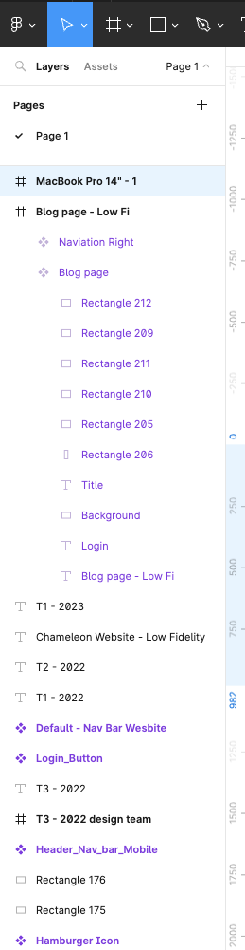

This is where all elements in Blog page are. If all elements are in the same folder, it is easier to edit later.

